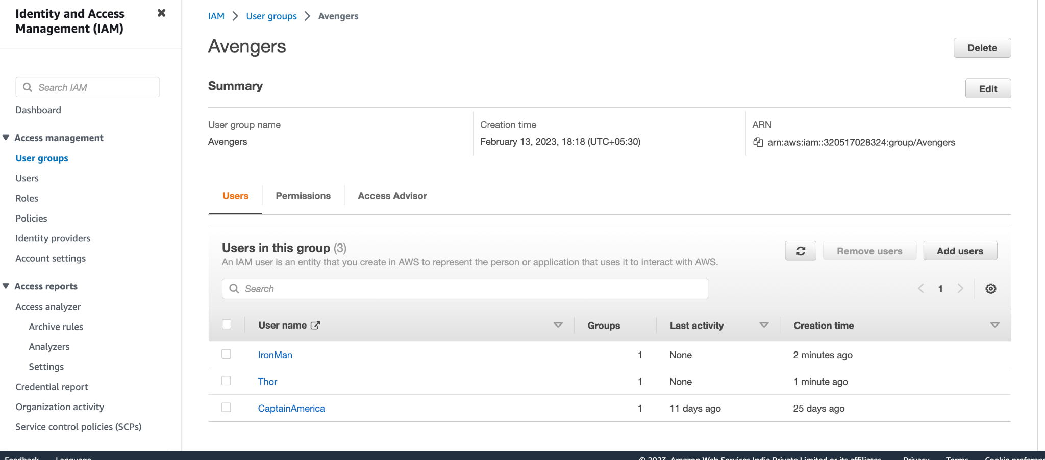  
  
15 MCQs for IAM  
  
What is IAM in AWS?

a. Infrastructure as a Service

b. Identity and Access Management

c. Input/Output Management

d. Integrated Analytics and Monitoring

How many AWS accounts can you have in an AWS organization?

a. Unlimited

b. 10

c. 5

d. 50

What is the maximum number of users that can be created in an IAM user account?

a. 5000

b. 100

c. 10

d. unlimited

What is the root account in AWS IAM?

a. The first AWS account created in an organization

b. The master account in an AWS organization

c. The default administrative account

d. None of the above

What is the purpose of IAM Roles in AWS?

a. To grant permissions to AWS services

b. To grant permissions to users within the AWS account

c. To grant permissions to EC2 instances

d. None of the above

What is an IAM policy in AWS?

a. A set of permissions granted to an IAM user

b. A set of permissions granted to an IAM role

c. A document that defines one or more permissions

d. None of the above

Can IAM policies be attached to both IAM users and IAM roles in AWS?

a. No, only IAM roles

b. No, only IAM users

c. Yes, both IAM users and IAM roles

d. None of the above

What is the maximum size of an IAM policy document in AWS?

a. 2 KB

b. 4 KB

c. 8 KB

d. 16 KB

What is the purpose of IAM Groups in AWS?

a. To grant the same permissions to multiple users

b. To grant permissions to multiple AWS services

c. To grant permissions to EC2 instances

d. None of the above

Can an IAM user belong to multiple groups in AWS?

a. No

b. Yes

c. It depends on the AWS account

d. None of the above

What is the purpose of IAM Access keys in AWS?

a. To grant programmatic access to AWS services

b. To grant console access to AWS services

c. To grant access to EC2 instances

d. None of the above

How often should IAM access keys be rotated in AWS?

a. Monthly

b. Quarterly

c. Annually

d. Every two years

What is the purpose of IAM Multi-factor authentication in AWS?

a. To add an additional layer of security to AWS access

b. To grant programmatic access to AWS services

c. To grant console access to AWS services

d. None of the above

What is the maximum number of access keys that can be created for a single IAM user in AWS?

a. 2

b. 5

c. 10

d. unlimited

Can IAM permissions be revoked in AWS?

a. No, once granted, permissions cannot be revoked

b. Yes, permissions can be revoked at any time

c. Permissions can only be revoked under certain conditions

d. None of the above